

Contact: Steve Tarter, Show Manager
1-800-700-7469
Steve@showcaseevents.net
FOR IMMEDIATE RELEASE

September 8, 2015

Media Fact Sheet

Event: Visalia Home Expo 14th Annual

When: September 25, 26, & 27, 2015
Friday: 11 a.m. to 6 p.m.
Saturday: 10 a.m. to 6 p.m.
Sunday: 10 a.m. to 5 p.m.

Where: Visalia Convention Center

Ticket Prices:
FRIDAY: Adults……….……………………$5.00 Seniors (62+)…….. $4.00
SAT. & SUN. Adults……….……………………$7.00 Seniors (62+)…….. $5.00
Children Under 12 and Parking is Free

Show Highlights
This Fall the Home EXPO has returned to 3 days and here are a few highlights of some of the products and services being featured at over 250 exhibits:

FALL REDECORATING: Talk with the experts at REM SLEEP SOLUTIONS and enter to win a Queen Size sleep system; or get organized and make better use of your living space with great looking and comfortable wall beds from PACIFIC MANUFACTURING; and check out the many treasures on display at the GALANTE DEZIGNERS booth and enter to win a nice piece of framed Cowboy art.

RENOVATING & HOME IMPROVEMENT: Let local experts at DL TOTTY CONSTRUCTION review your plans to remodel the kitchen, bath or add a new room; or enhance your home security with uniquely designed security screens from CLEARVIEW OF THE CENTRAL VALLEY, and stop by and talk with local city inspectors from the CITY OF VISALIA BUILDING DIVISION about ways to ensure family safety when it comes to repairs, remodels, or construction projects.

WIN A DREAM CAR: Try your luck at cracking a 6-digit code to open a vault and win $50,000 which you can use to finance your dream car from ED DENA’S AUTO CENTER – and check the great vehicles and deals he has to offer at his new Visalia location.

HOME THEATER: Don’t miss any of the new fall programs when you let STAR WIRELESS show you the latest deals on popular Direct TV packages, including the NFL Sunday Ticket; and enter to win two tickets to a 49er game at Levi Stadium.

WATER CONSERVATION: Talk with GRASS CREATIONS about waterless landscaping options, and stop by the CAL WATER booth for conservation tips ways to save money on your next bill.

HOME IMPROVEMENT LOANS: Talk with local reps from TUCOEMAS FEDERAL CREDIT UNION about how to finance your next project and enter to win Disneyland Resort Hopper Passes.

DO-IT-YOURSELF PROJECTS: Learn new painting techniques at the PAINT BAR from experts at EMBELLISH & RESTORE.

DINING & ENTERTAINING: Sample tasty treats by two culinary experts from the INSTITUTE OF TECHNOLOGY during weekend cooking demonstrations; and sample the great German KING FROSH wine and enter to win one of their daily giveaways.

MARKETPLACE PRODUCTS: Visit the crafter area and shop at local companies like SOAPTACULAR, started by two young entrepreneurs, that specializes in handmade soaps, scrubs and bath products; or learn to inexpensively repair unsightly nicks and scratches on your walls with an easy to use paint touch up tool from FIX-A-NIC; and enjoy top quality nuts, dried fruits, and hand-made items including nut butters, sugar free clusters, and caramel pecan logs from NATURALLY NUTS.

FALL DINING

Join our celebrity chefs from the Institute of Technology’s Culinary Academy as they prepare delicious dishes and desserts that will enhance your next family get-together or dinner party.

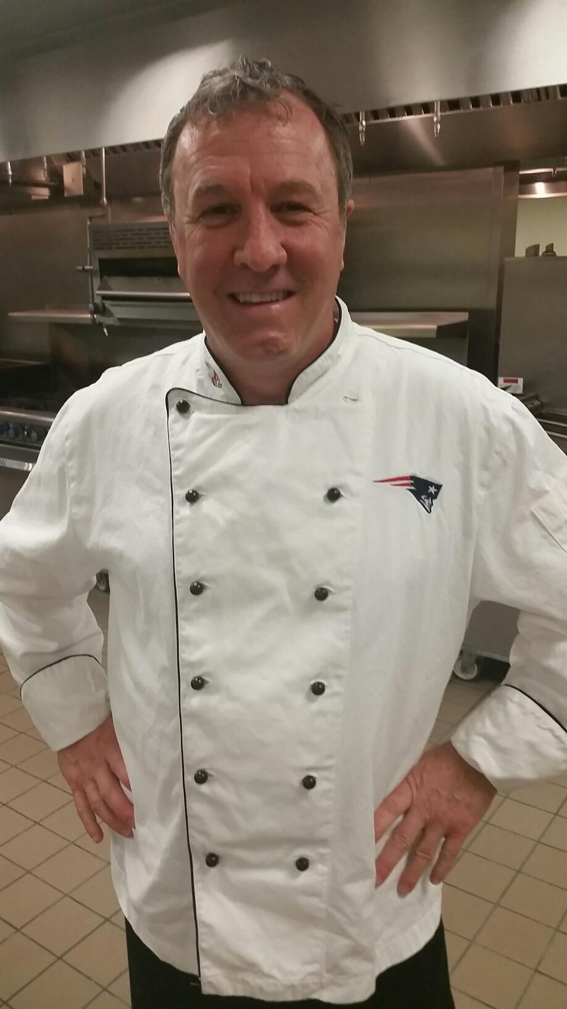
SATURDAY, September 26th

Chef Thomas Nelson

Noon Spaghetti Squash

3pm Acorn Squash

With over 35 years of culinary experience, Chef Thomas Nelson currently teaches at the Institute of Technology’s Culinary Arts Academy. In addition to curriculum planning and implementation including creative menu development and specialty cuisine presentation, he participates as a mentor and coach, ensuring that each student get assistance in job placement

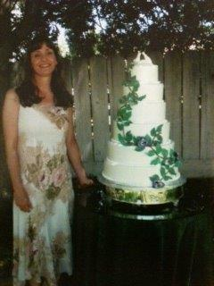
SUNDAY, September 27th

Chef Erin Easley
Noon Salted Caramel Cream Puffs Dipped in a Chocolate Glaze

3pm Meringues

Chef Erin Easley has always had a strong passion for baking since as a young girl she watched her mother make Nestle Tollhouse cookies. So after raising her three sons, Chef Erin attended culinary school and then had the privilege to participate in an intense in-depth study under a Master Baker from Holland which included all aspects of baking, specializing in custom cakes with fondant. Today she teaches baking classes at Creative Cakes, located in Clovis and also teaches in private homes.

Kids Activities

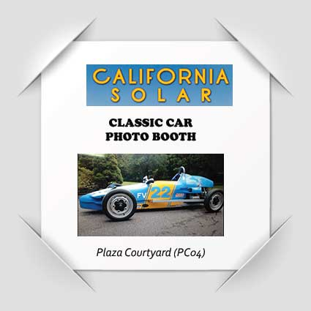

California Solar will hosting a photo booth where kids can sit inside a classic race car and polaroid photos will be provided to parents who stop by their inside booth.

ENTER TO WIN LOTS OF SHOW PRIZES:

Ed Dena’s Auto Center is also inviting the public an opportunity to select a 6-digit code to crack the vault and win $50,000 to spend in on a dream car. It is open to the first 5,000 attempts and if no one cracks the code, the lucky numbers will be available for inspection at the close of the show. In addition, there will be random consolation prizes awarded some of the tries.
Here are other prizes being offered by a number of participating merchants:

- Queen Size Bed REM SLEEP SYSTEMS
- Two 49er Tickets to Levi Stadium ELITE SATELLITE SYSTEMS
- Disneyland Resort Hopper Passes TUCOEMAS FED CREDIT UNION
- Framed Poster by Bob Coronato GALANTE DEZIGNER GALLERY
- King Frosh Imported German Wine KING FROSH WINES
- Gift Basket with shopping spree Gift Cards VISALIA MALL

#######

